TITLE | Honorary Researcher Appointments
TARGET AUDIENCE | External researchers or individuals without a current appointment as a Cabrini employee
SCOPE | All Cabrini Sites and Services

PURPOSE
The purpose of this document is to outline the procedures for Cabrini Health (Cabrini) Honorary Researcher Appointments.
This procedure applies to all individuals that do not have a current appointment as a Cabrini employee and are involved in a project that requires one or more of the following:
• On site access to non-public areas of Cabrini premises for research purposes
• Contact with Cabrini patients
• Access to Cabrini data, systems, or medical records
• Other responsibilities involving Cabrini patients, staff, resources, facilities

DEFINITIONS
Honorary Researcher Appointees: are persons for whom Cabrini Health collaborates with for the purposes of research or education. Honorary appointees are not employees or contractors.

The Principle Investigator (PI): is expected to conduct objective research that generates independent, high quality, and reproducible results. The PI is responsible for the management and integrity of the design, conduct, and reporting of the research project and for managing, monitoring, and ensuring the integrity of any collaborative relationships.

PROTOCOL
All appointees will be required to complete a Cabrini Health Honorary Research Appointment/Reappointment Checklist and Approval Form. The appointee can refer to the Cabrini Health Honorary Researcher Appointment Eligibility Flow chart (Appendix 1) for guidance. The PI sponsoring the honorary appointment will ensure the Honorary Appointment/Reappointment Checklist and Approval form is completed by the applicant and includes all the requisite supporting documentation, including a duty statement or scope of the role, current curriculum vitae and professional registration (if appropriate). This documentation, including recommendations must then be forwarded to the Research Operations team at honoraryappointment@cabrini.com.au for approval.

However, the appointment is not valid without the following:
- The PI must ensure that the Honorary Researcher applicant completes Cabrini Health Orientation online and/or is provided with the local departmental support/contact.
- The Honorary Researcher applicant must provide immunisation evidence of COVID and current Influenza to the Research Operations team via email to honoraryappointment@cabrini.com.au

A letter of offer from the Director of Research Operations will then be sent to the Honorary Researcher Appointee. The Honorary Researcher Appointment acceptance and undertaking agreement in this letter must be signed and returned either via email or in person to Cabrini. The appointee will then be notified by the Research Operations team when the application is finalised. Appointees must not commence any research activities until they have received written confirmation that the appointment is finalised by both the Research Operations team and Cabrini Research Governance Office.

The PI must ensure the appointee adheres to all institutional safety standards, privacy policies and other Cabrini policies during the conduct of the research at Cabrini and that all publications resulting from their research will give appropriate acknowledgement to Cabrini.

The maximum length of a term of appointment will be 2 years. The procedure to be followed for any extension to an appointment is the same that applies for making the initial appointment.

If an appointee is no longer involved in research at Cabrini Health, the PI must notify the Cabrini Research Governance team and Research Operations team, and any permission(s)/access granted to the appointee will be withdrawn. An Honorary Researcher appointment may be withdrawn or terminated at any time by Cabrini Health and / or the appointee.

Students on placement at Cabrini which may include research activities are covered under the student placement arrangements between the University and Cabrini and are therefore exempt from requiring an Honorary Researcher Appointment.

REQUIREMENTS
- Cabrini Health Honorary Researcher Appointment Application Form
- Cabrini Honorary Appointment Letter (on-site/off site) and acceptance of undertaking agreement

REVIEW
This protocol will be reviewed every two years or earlier if required.

EVALUATION
Processes and procedures are evaluated within the context of organisation risk management accreditation and legislative standards.

REFERENCES and ASSOCIATED DOCUMENTS
All relevant Industrial Awards/Agreements/Individual contracts binding on Cabrini Health services.

APPENDIX 1. ELIGIBILITY FLOWCHART

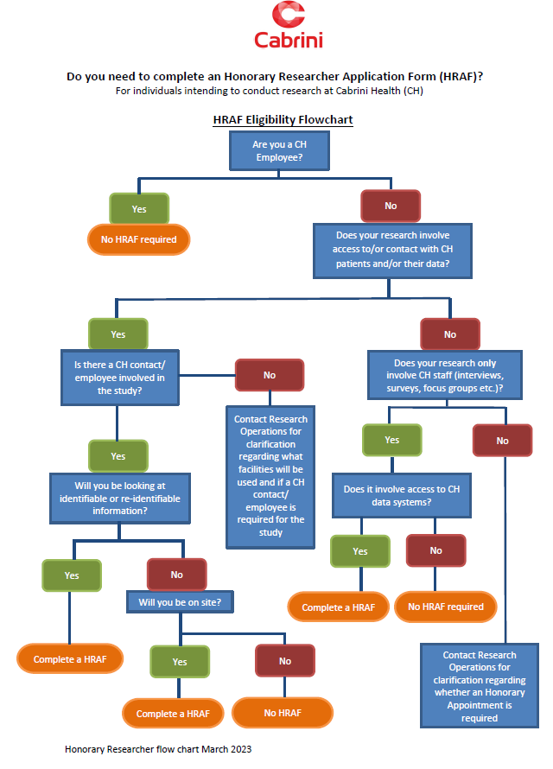

Executive Sponsor | Group Director, Cabrini Research
Approved By: | Cabrini Research Governance Committee | Date: 26 August 2024
Authorised By: | Cabrini Research Governance Committee | Date: 26 August 2024

